**CLASS WORK PROGRAMS**

# C Program to Reverse a Number Using FOR Loop.

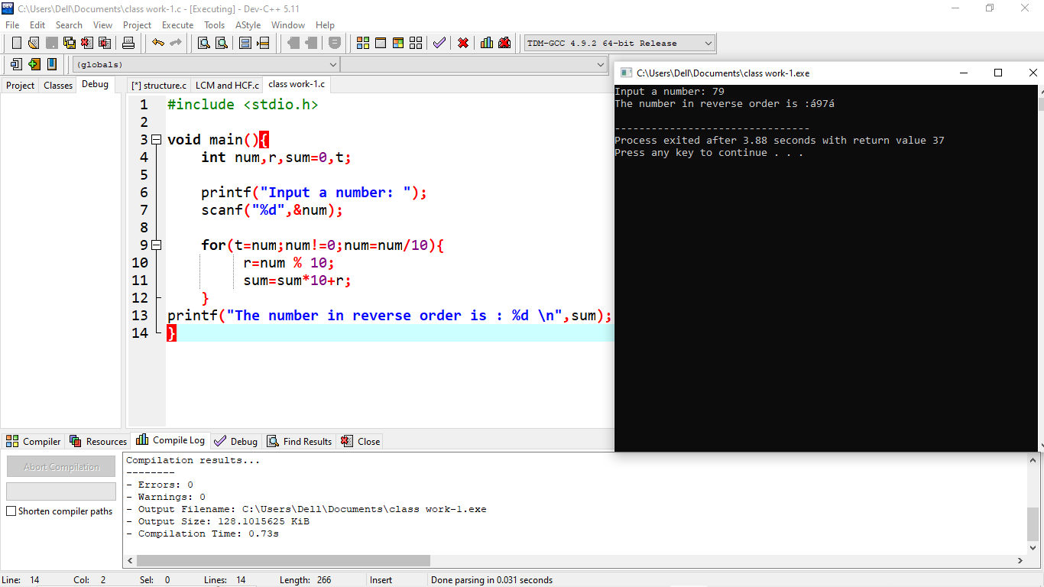

1. Write a program in C such that the program will read the elements of a one-dimensional array, then compares the elements and finds which the largest two elements are in a given array.

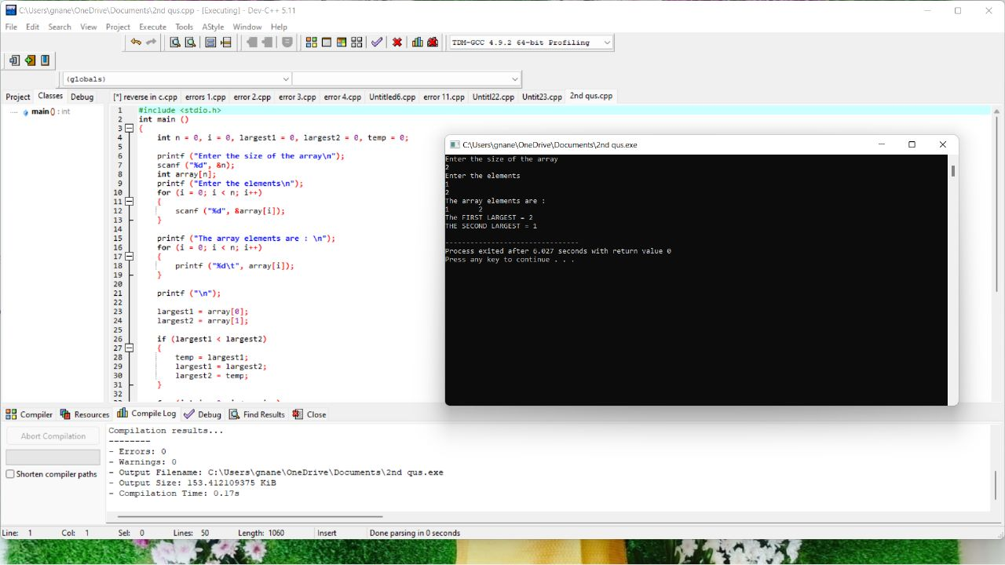

1. kth smallest element is the minimum possible n such that there are at least k elements in the array <= n. In other words, if the array A was sorted, then A[k - 1] ( k is 1 based, while the arrays are 0 based )C Program for finding the desired kth smallest element in an array.

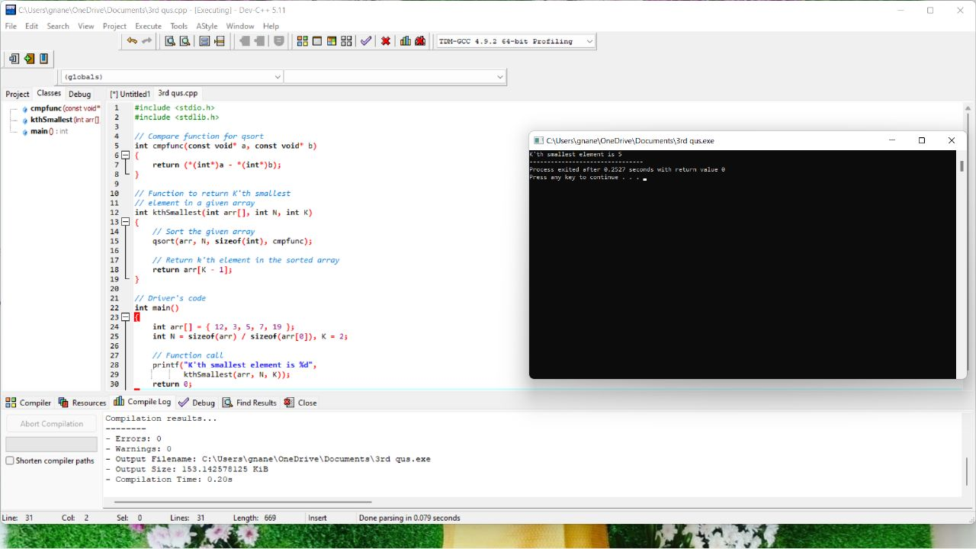

1. Write a program to search the given element using binary search method and display its position in a linear array.

Sample Input;

Array of elements = {28, 12, 15, 122, 10, 33, 11}

Element to search = 15

SampleOutput:  
Given element 23 is found at 3 rd position

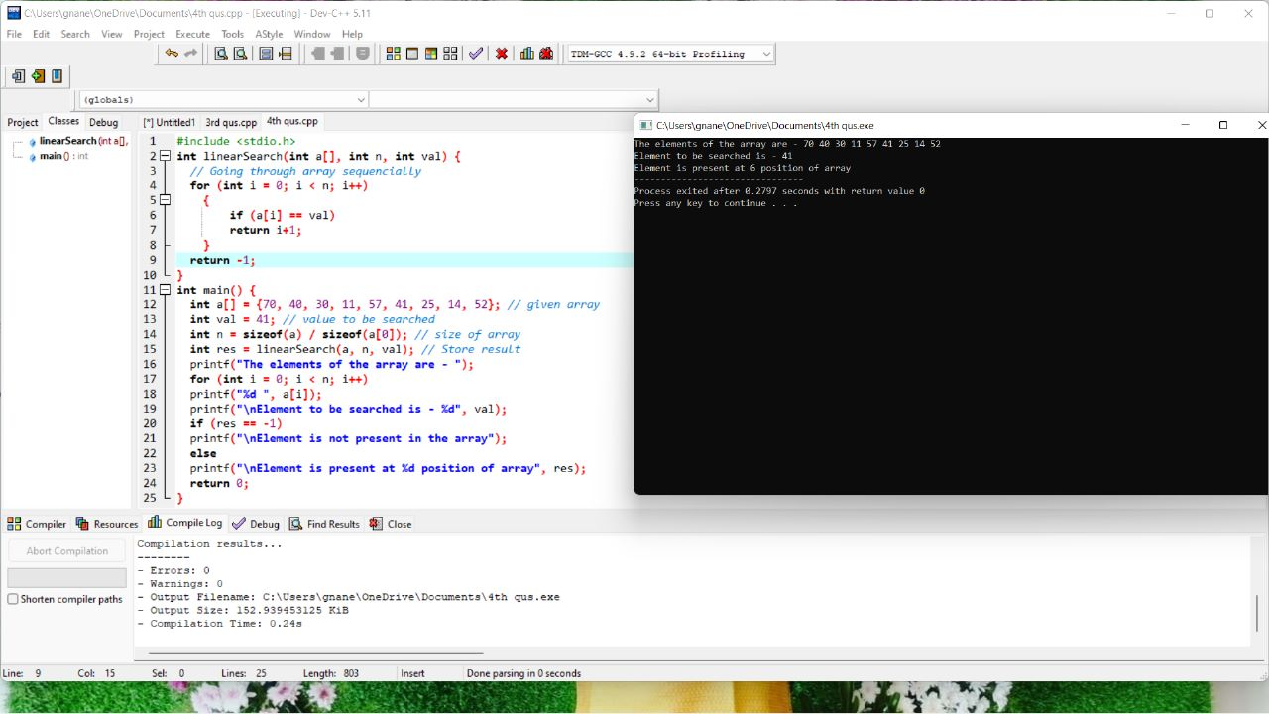

# C Program to Find Sum of Natural Numbers Using While Loop

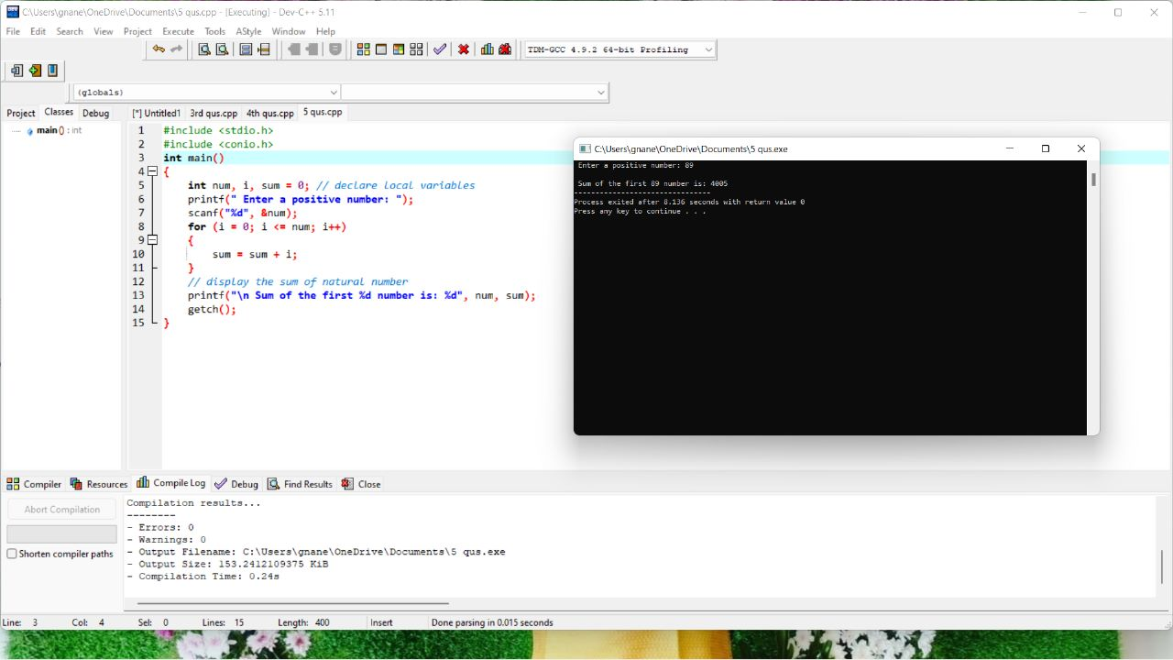

# C Program to Find GCD of two Numbers Using For Loop

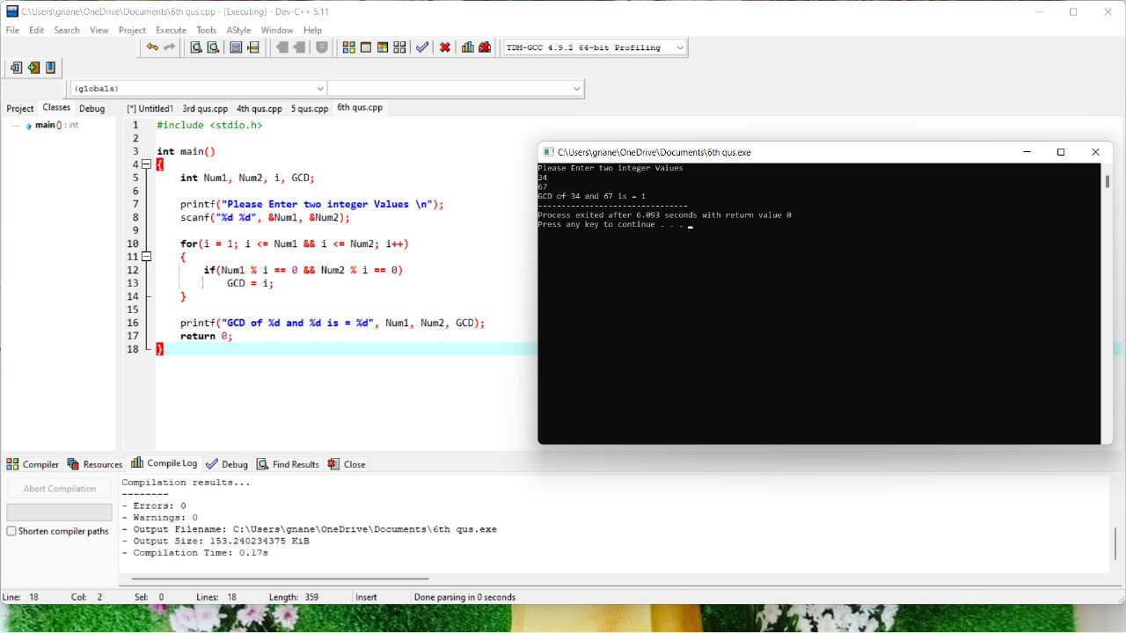

1. Predict the output or error(s) for the following program

main()  
{  
int i=5;  
printf("%d%d%d%d%d%d",i++,i--,++i,--i,i);  
}

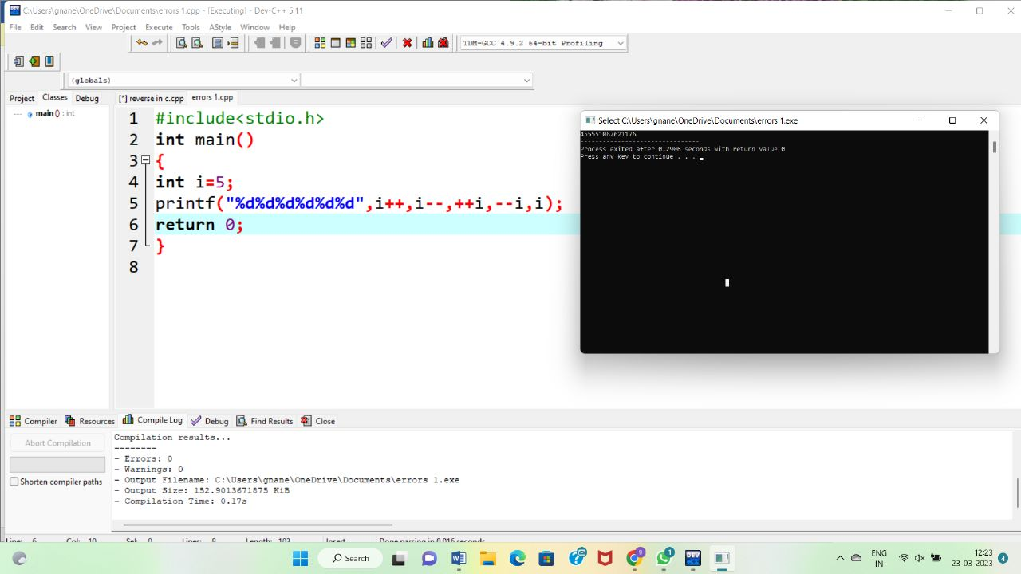

8. Predict the output or error(s) for the following program

main()  
{  
char s[ ]="man";  
int i;  
for(i=0;s[ i ];i++)  
printf("\n%c%c%c%c",s[ i ],*(s+i),*(i+s),i[s]);  
}

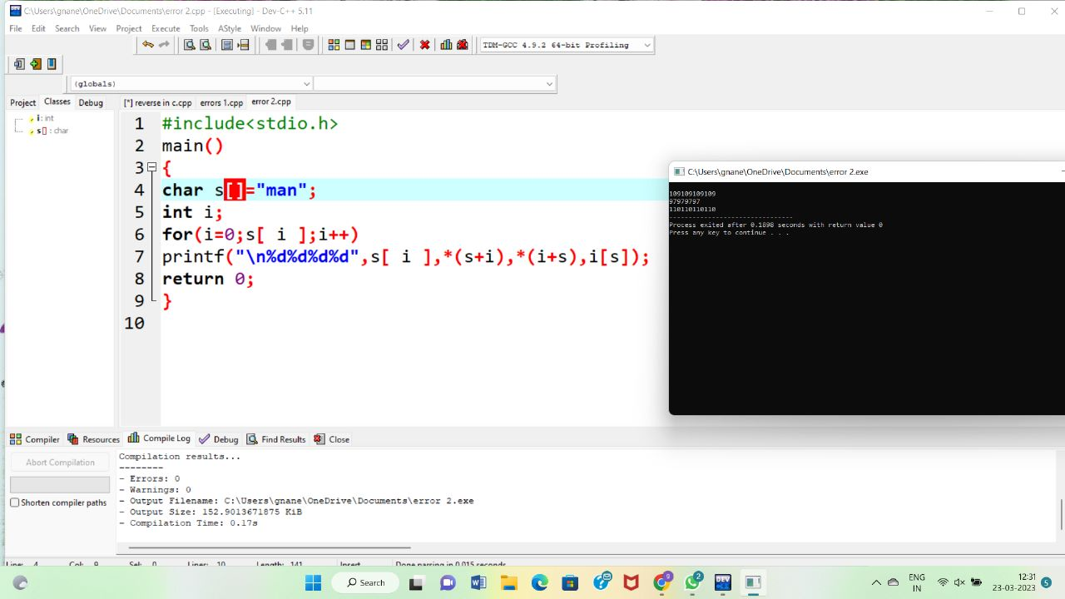

9. Predict the output or error(s) for the following program

 #include<stdio.h>

main()  
{  
char s[]={'a','b','c','\n','c','\0'};  
char *p,*str,*str1;  
p=&s[3];

str=p;  
str1=s;  
printf("%d",++*p + ++*str1-32);  
}

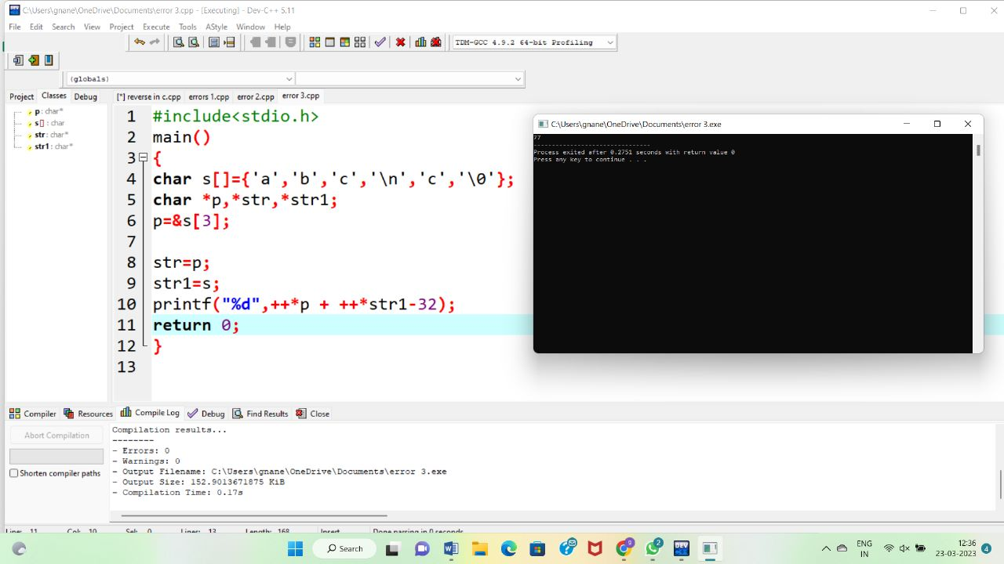

10. Predict the output or error(s) for the following program

main()

{  
struct xx  
{  
int x;  
struct yy  
{  
char s;  
struct xx *p;  
};  
struct yy *q;  
};  
}

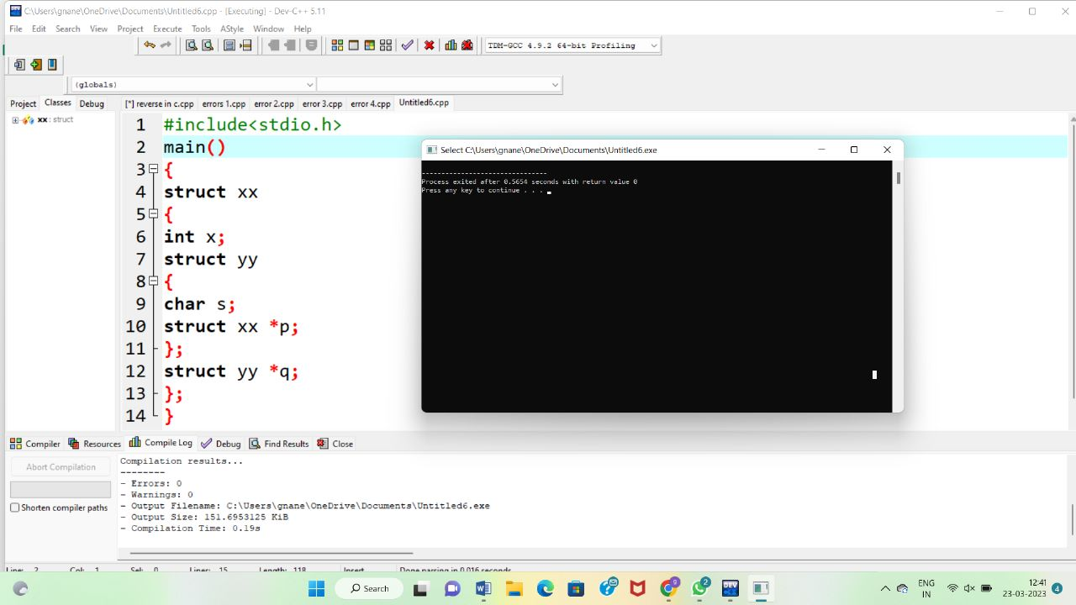

11. Predict the output or error(s) for the following program

main()  
{  
char *p;  
p="Hello";  
printf("%c\n",*&*p);  
}

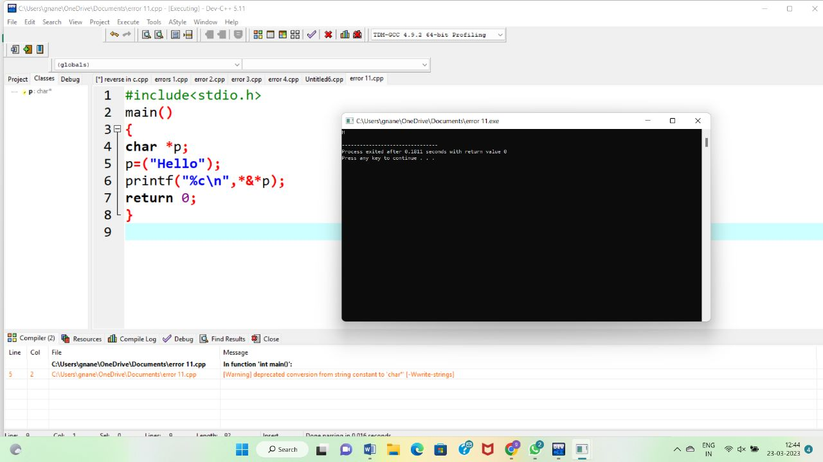

1. Write a program to enter the marks of n student in four subjects using structure. Then calculate the total and aggregate, display the grade obtained by the student. If the student scores an aggregate greater than 75%, then the grade is Distinction. If aggregate is 60>= and <75, then the grade is First Division. If aggregate is 50 >= and <60, then the grade is Second Division. If aggregate is 40>= and <50, then the grade is Third Division. Else the grade is Fail.

Sample Input & Output:

Enter the marks in python: 90

Enter the marks in c programming: 91

Enter the marks in Mathematics: 92

Enter the marks in Physics: 93

Total= 366

Aggregate = 91.5

DISTINCTION

Test cases:

1. 18, 76,93,65

2. 73,78,79,75

3. 98,106,120,-95

4. 96,73, AA,95

5. 78,59.8,**,79

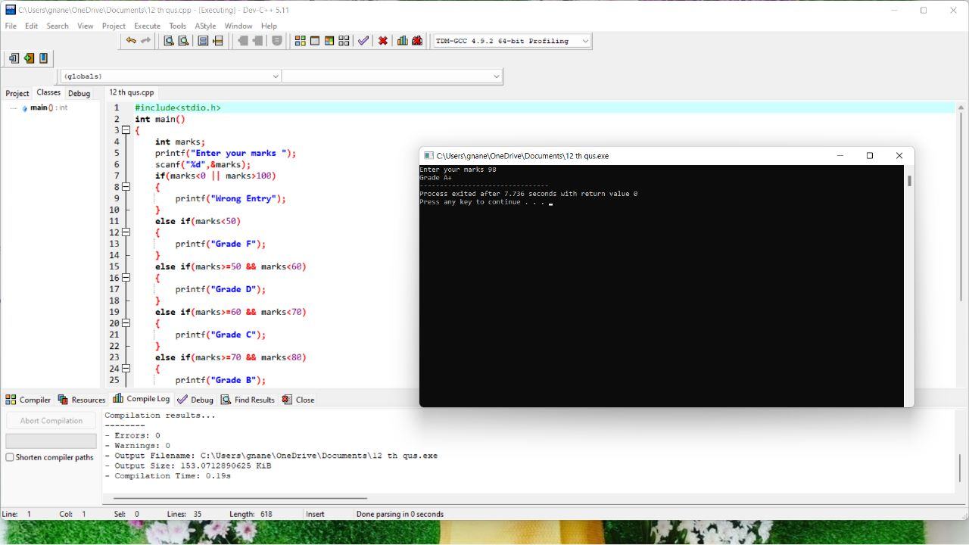

13. Print the following hill pattern

A B C D E D C B A

  A B C D C B A

    A B C B A

      A B A

        A

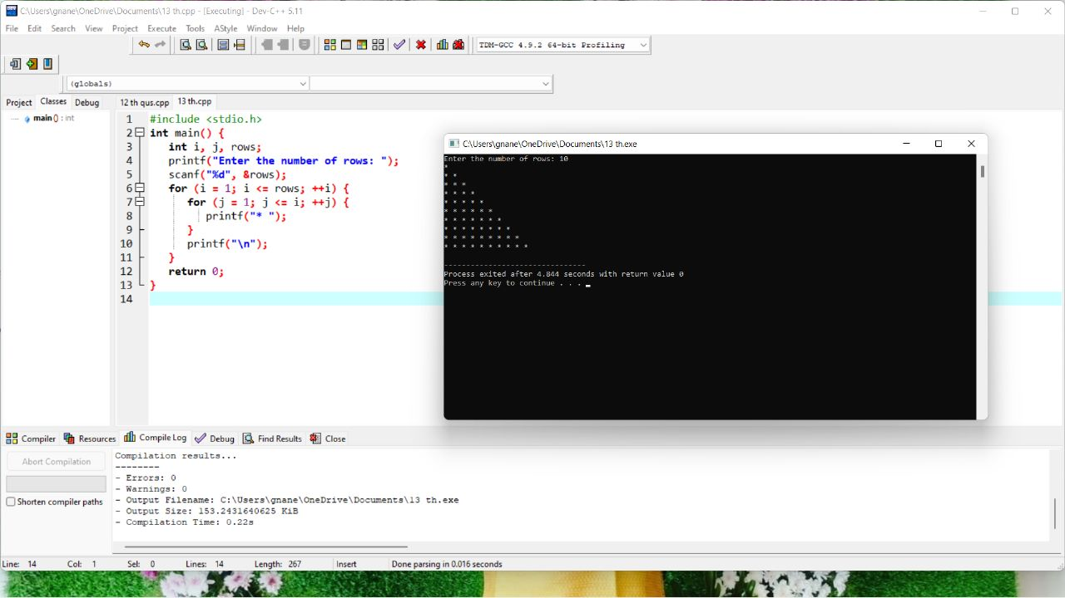

1. Write a program for matrix multiplication?

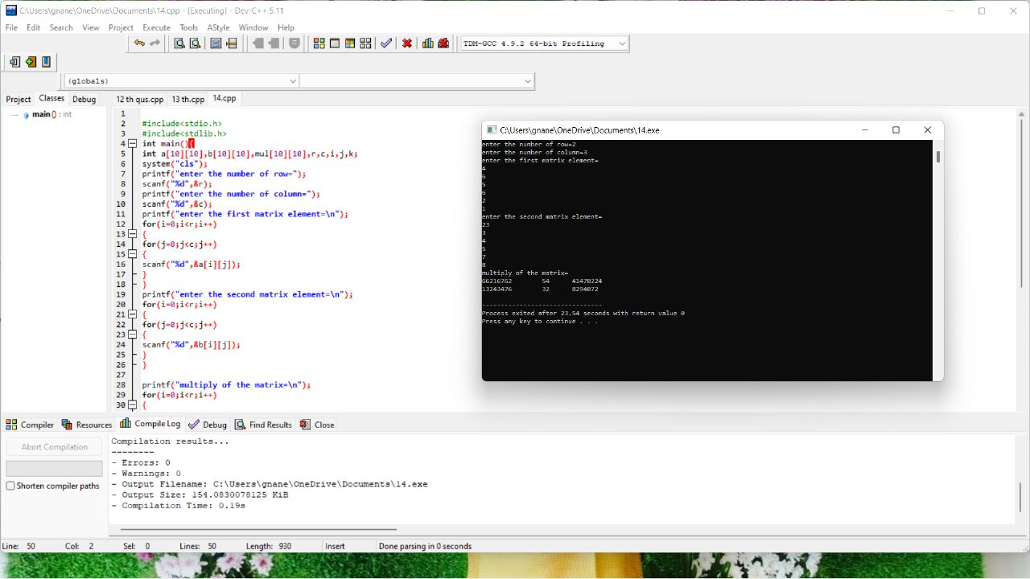

1. Write a Program to display the diagonal elements in a matrix array and also find the sum of them.

Sample input:

1 4 3

4 2 6

7 1 3

Output:

Diagonal Elements are 1 2 3

Sum of diagonal elements = 6

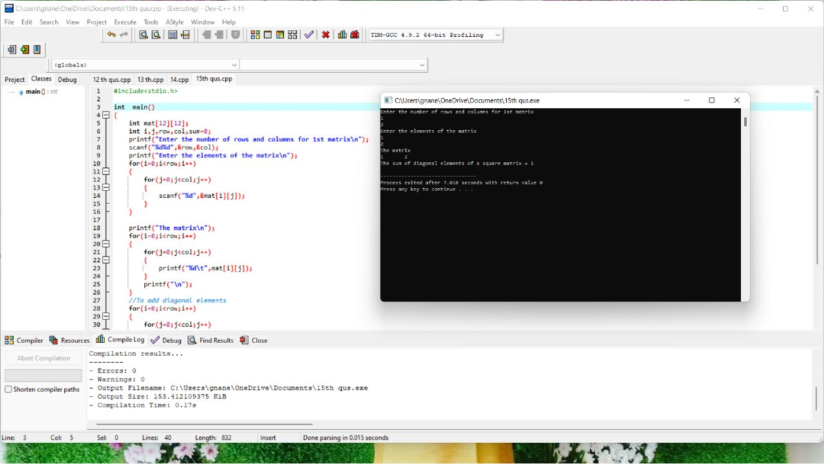

1. Write a program in C to swap elements using call by reference.

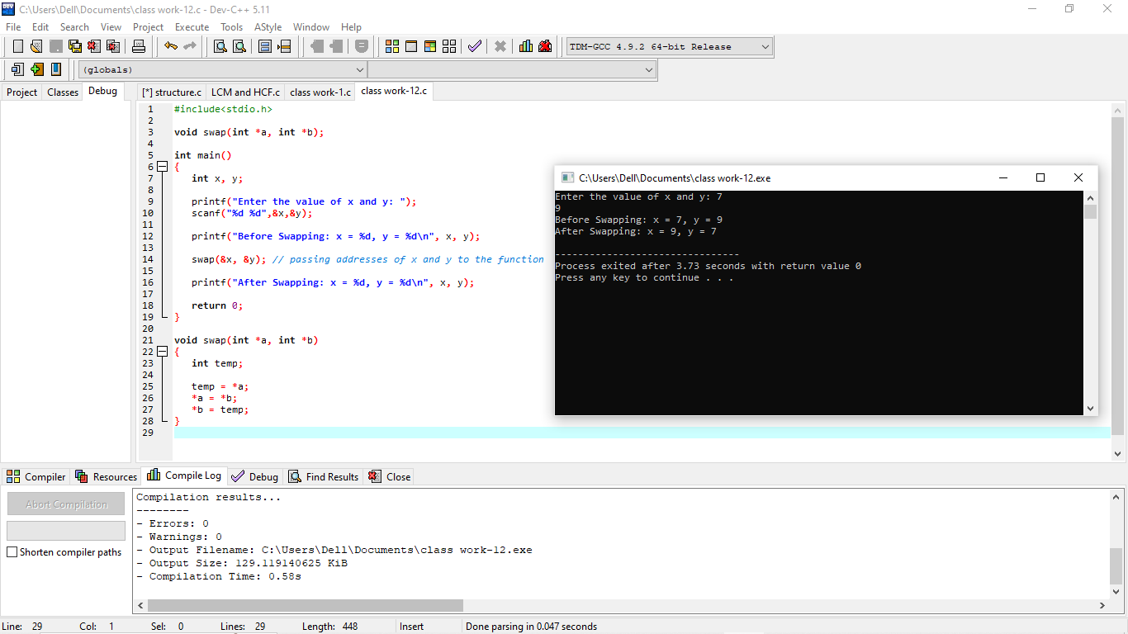

1. Write C program to Copy file contents to another file.

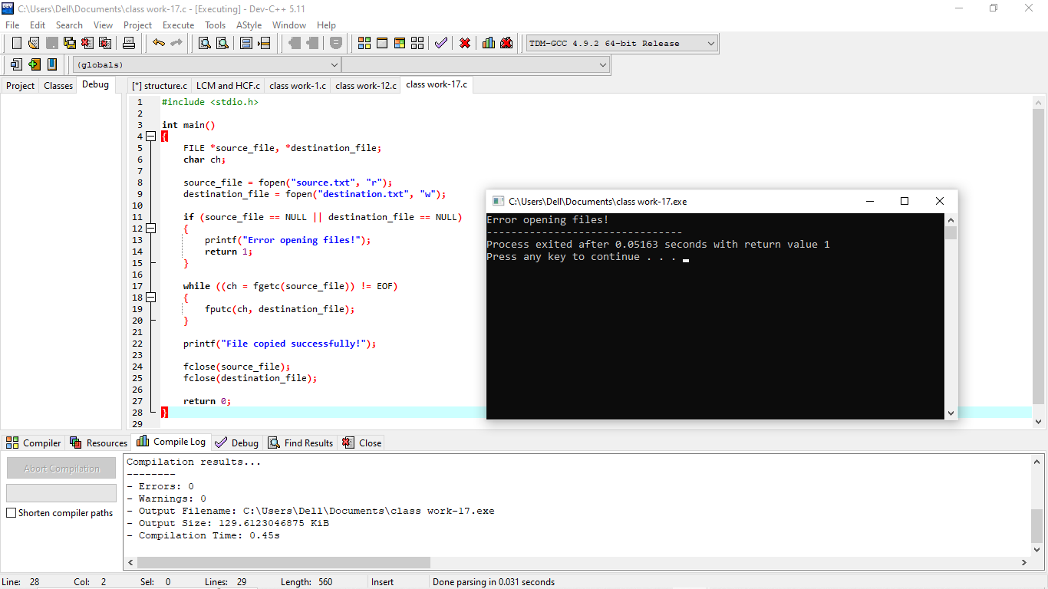

1. Write a program in C to read the file and store the lines into an array.

Test Data :  
Input the file name to be opened : test.txt  
*Expected Output* :

The content of the file test.txt are :

test line 1

test line 2

test line 3

test line 4

Test cases

Sample.txt

sample1.txt

S123.txt

S@12.txt

Sample S.txt

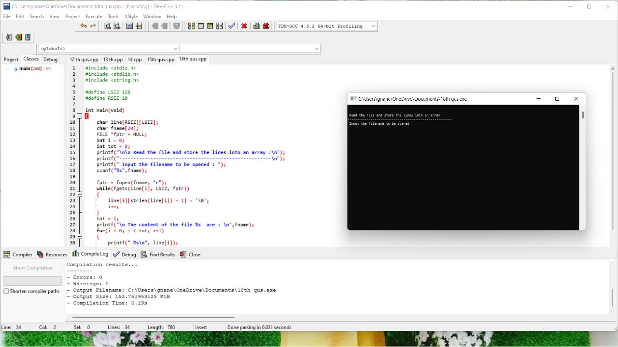

1. Two strings consisting binary value of two numbers. Print the sum of the numbers in binary.

Input1: s1=“1101” , s2=“100101”

Result: “110010”

Input2: s1=“1111001001111101” , s2=“10000”

Result: “1111001010001101”

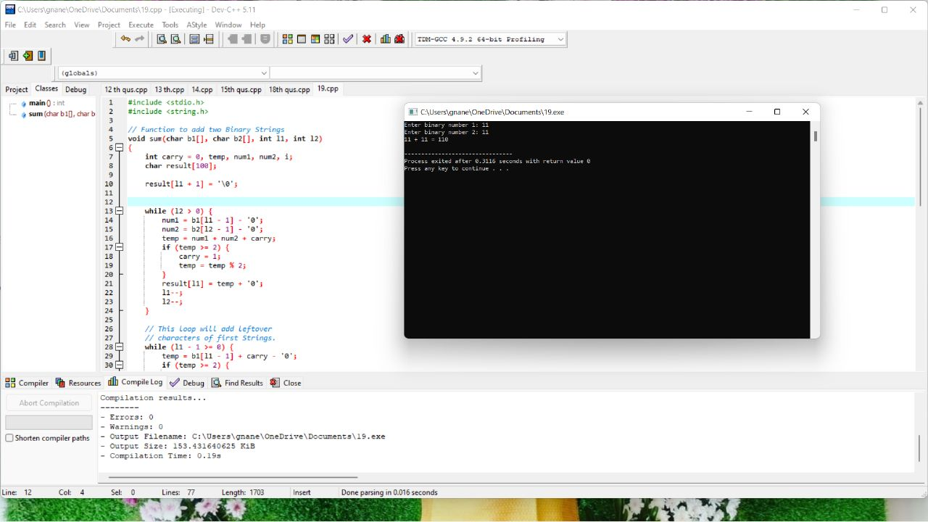

1. Write a Program to illustrates the use of continue statement.

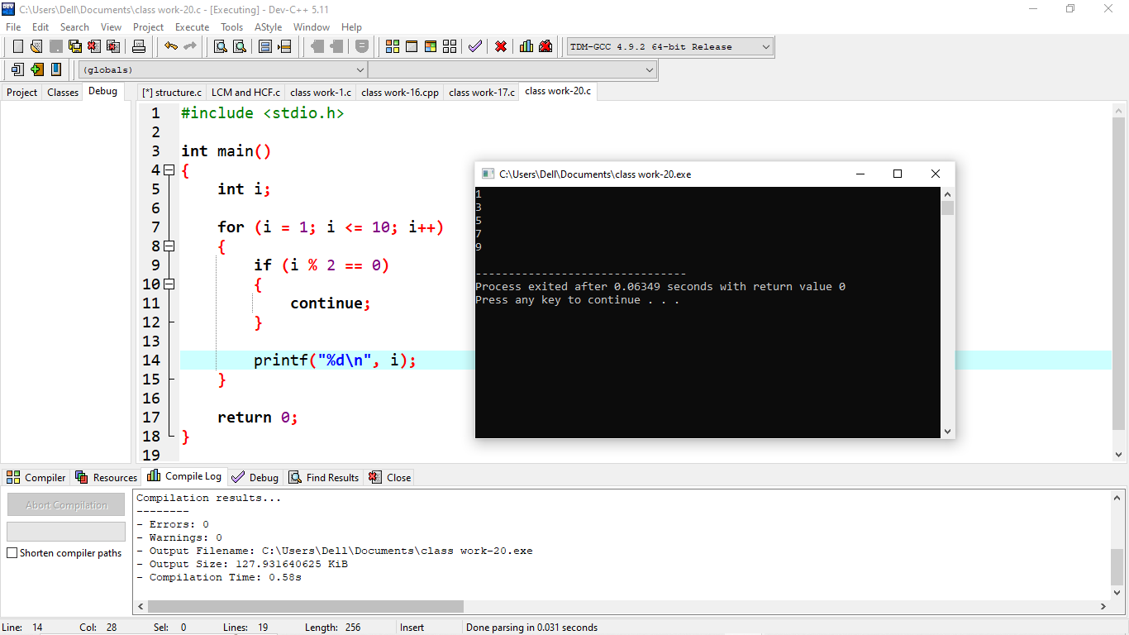

1. Write a program to calculate square and cube of an entered number. Use function as an argument

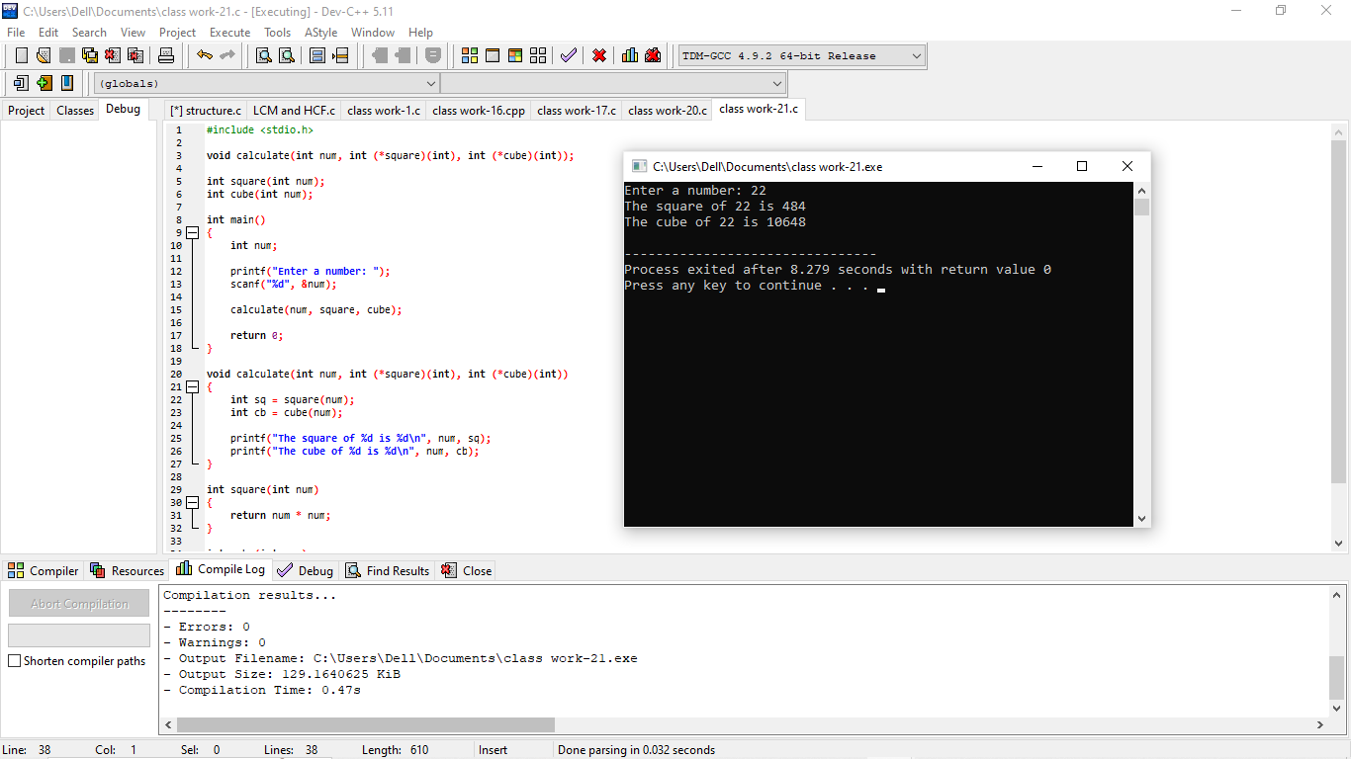

1. What is the output of the program given below?

main()

{

signed char i=0;

for(;i>=0;i++) ;

printf(“%d\n”,i);

}

22. What is the output of the program given below?

int aaa()

{

printf(“Hi”);

}

int bbb()

{

printf(“hello”);

}

int ccc()

{

printf(“bye”);

}

main()

{

int ( * ptr[3]) ();

ptr[0] = aaa;

ptr[1] = bbb;

ptr[2] =ccc;

ptr[2]();

}

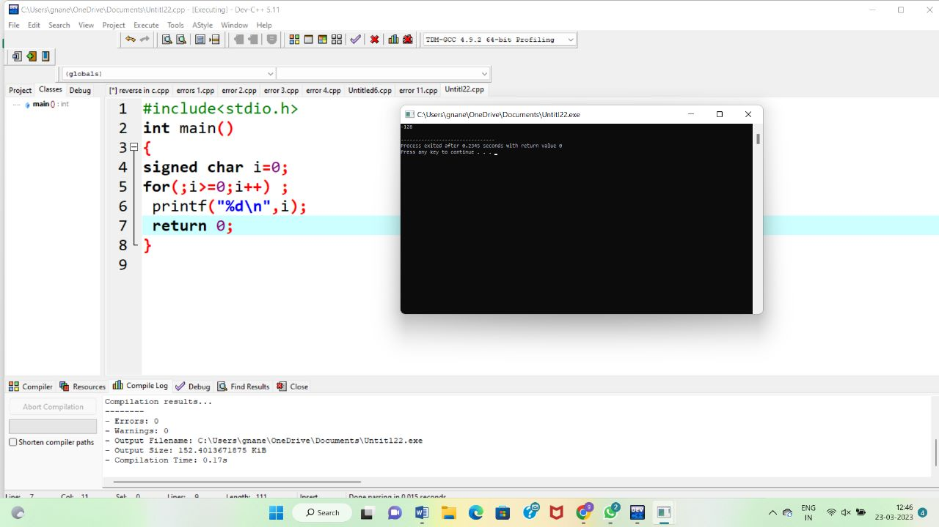

1. Find out the logic missing statements and display the final output.

#include <stdio.h>

#include <conio.h>

main()

{

int i, n, d, sum;

clrscr();

printf("Armstrong numbers : "); for(i=2; i<=1000; i++)

{

sum = 0;

n = i; while(n)

{

sum = sum + (d * d * d); n = n / 10;

}

if (sum == i) printf("%d ", i);

}

getch();

}

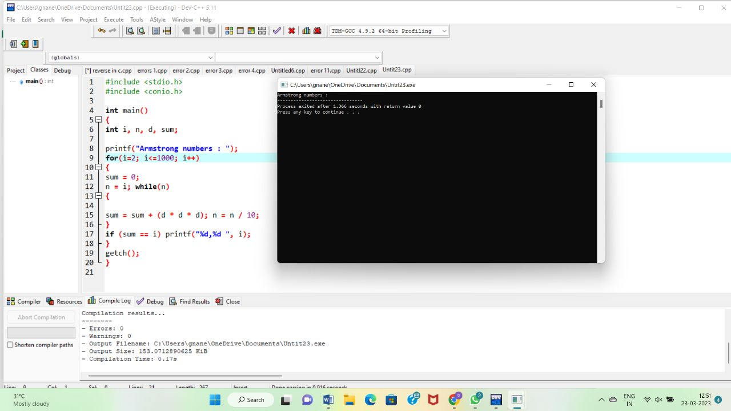

1. To generate employee payroll for an organization using structure.
   1. Define *employee* structure with fields *empid*, *ename*, *basic*, *hra*, *da*, *it*, *gross* and

*netpay*

* 1. Read number of employees *n*
  2. Read *empid*, *ename*, and *basic* for *n* employees in an array of structure.
  3. For each employee, compute hra = 2% of basic

da = 1% of basic

gross = basic + hra + da it = 5% of basic

netpay = gross - it

* 1. Print *empid*, *ename*, *basic*, *hra*, *da*, *it*, *gross* and *netpay* for all employees

1. To implement a simple calculator using switch case statement.

Read the *operator* symbol and operands *n1*, *n2*

If *operator* = + then calculate *result* = *n1* + *n2*

Else if *operator* = – then calculate *result* = *n1* – *n2*

Else if *operator* = * then calculate *result* = *n1* * *n2*

Else if *operator* = / then calculate *result* = *n1* / *n2*

Else if *operator* = % then calculate *result* = *n1* % *n2*

Else

print "Invalid operator"

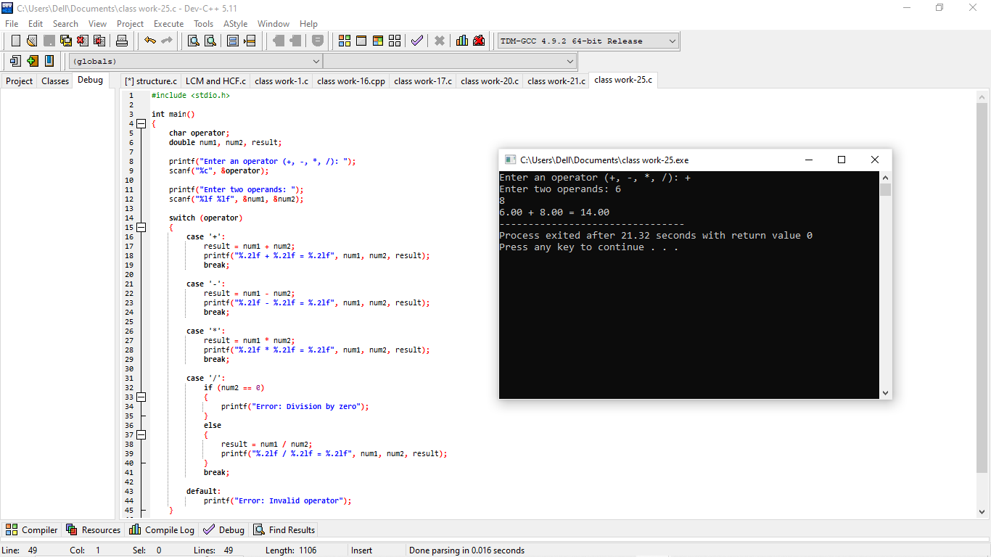

1. To find the sum of the digits of a given number using while statement. .

Read *num*

Initialize *sum* to 0.

Repeat until *num* = 0

Obtain last digit *d* = *num* % 10 Add *d* to *sum*

*num* = *num* / 10

Print *sum*

